
Diotranics Enterprises Limited
Specialist in; borehole drilling and services, Electrical works, supplies and services, Engineering works, solar backups and services, cctv, Electric fence, Intercom, Intrusion Plumbing serices

Tarino Building Namanga Road
Kitengela
P.O. Box 306  00241 Kitengela Contact: 0721423793/0799524922
Email: info@diotranics.co.ke
Web: www.diotranics.co.ke
PIN NO. P051697866F
QUOTATION

ZION CHILDREN'S HOME,
CF/8995/2026,
26/06/2026.
Dear Sir,
QTY | UOM | DESCRIPTION | UNIT COST | TOTAL | D/Note
24 | PCS | SOLAR PANELS | 17,300.00 | 415,200.00
3 | PCS | 10.56KWH LITHIUM BATTERIES | 290,780.00 | 872,340.00
1 | PC | HYBRID INVERTER | 245,500.00 | 491,000.00
4 | PCS | SURGE ARRESTORS | 8,920.00 | 35,680.00
1 | SET | LIGHTENING ARRESTOR | 6,500.00 | 6,500.00
2 | PCS | MAIN SWITCHES | 5,500.00 | 11,000.00
2 | PC | COMBINER BOX | 8,200.00 | 16,400.00
1 | LOT | 25MM PIPES AND ACCESSORIES | 5,500.00 | 5,500.00
1 | SET | ACCESSORIES | 7,500.00 | 7,500.00
16 | PAIRS | MC4 CONNECTORS | 800.00 | 12,800.00
4 | PAIRS | 3Y-MC4 CONNECTORS | 1,500.00 | 6,000.00
2 | PC | ADAPTOR BOXES | 650.00 | 1,300.00
4 | PCS | DC BREAKERS | 7,400.00 | 29,600.00
60 | MTS | SOLAR CABLE RED | 340.00 | 10,200.00
60 | MTS | SOLAR CABLE BLACK | 340.00 | 10,200.00
90 | MTS | EARTH CABLE | 170.00 | 15,300.00
1 | PC | EARTH ELECTRODE | 3,500.00 | 3,500.00
30 | MTS | 6.0MM SOLAR AUTO CABLE | 230.00 | 6,900.00
1 | SET | SOLAR STRUCTURE AND FABRICATION | 84,500.00 | 84,500.00
2 | SETS | 300LT SOLAR WATER HEATING AND ACCESSORIES | 215,000.00 | 430,000.00.00
 |  |  | SUB TOTAL | 2,471,420.00
 |  | ELECTRICAL INSTALLATION COMMISSIONING AND TESTING |  | 130,630.00
 |  |  | DISCOUNT | 50,000.00
 |  |  | V.A.T | 62,961.60
 |  |  | GRAND TOTAL | 2,615,011.60

Business terms

Delivery :immediate upon approval
Quatation validity. :30 working days
Payment terms :80% upon approval and 20%after installation, commissioning and testing
Inquiries. :undersigned

YABESH ONGIRI OSINDE
Technical Director 0721423793

Payment Instructions:
Bank Details:

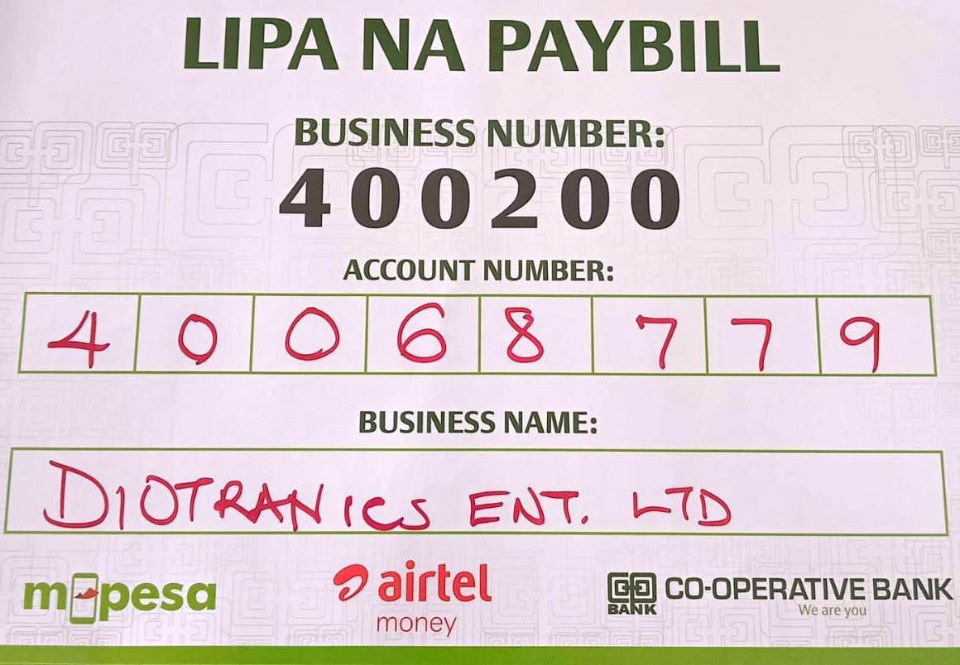
ACCOUNT DETAILS:
BANK NAME :COOPERATIVE BANK OF KENYA
ACCOUNT NAME :DIOTRANICS ENTERPRISES LTD
ACCOUNT NUMBER :01192946387900
PAYBILL :400200
PAYBILL NUMBER :40068779
BRANCH NAME :DONHOLM
BRANCH CODE :11087
BANK CODE :11000
SWIFT CODE :KCOOKENA

Your Efficient & Reliable Partner in electrical and supplies Works.


